Title |  | Asbestos Containing Materials
Scope |  | Applies across all VU Campuses – Buildings Erected Pre 1990
Why |  | Explain health risks and controls for Asbestos Containing Materials - ACM  The current labels showing asbestos is present are being replaced with new labels.
What |  | Asbestos is a naturally occurring mineral with excellent insulating properties and strength. Asbestos containing materials are present in many buildings across Australia particularly those erected before 1990.
VU Examples |  |  |  | 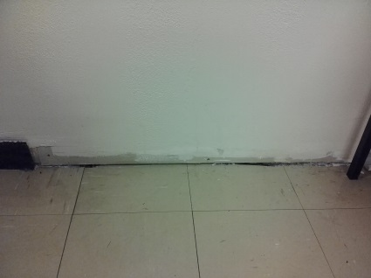
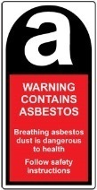
Old Label | New Label
Photos |  | Fig 1: Old Cement Sheeting in panels or walls. |  | Fig 2: Vinyl floor tiles or glue beneath tiles |  | Fig 3. Fire Doors with inside core containing asbestos
Most Risk |  | Asbestos fibres present health risks when abestos fibres become airborne and are inhaled.  Where asbestos is bound in a matrix, for example asbestos within vinyl floor tiles, painted and undamaged cement sheeting, tile glue, or sealed inside fire doors, the contained asbestos poses practically no risk as it cannot be inhaled.
Victoria University |  | Labels are present to indicate the locations of materials containing asbestos to everyone and to minimise the risks of disturbance by drilling and other maintenance.  All Victoria University buildings have been audited by consultants and registers of asbestos containing materials have been compiled for every building at every VU campus. These can be accessed by any staff member via the Intranet.
Health Risks |  | Frequent inhalation of higher concentrations of asbestos fibres can cause asbestosis – scarring of the lungs or mesothilioma – cancer of the lung external lining or  lung cancer. Due to the previous prevelance of asbestos in older building materials, car brakes, and insulating materials, most people have some asbestos fibres in their lungs with no health impact.
Regulations |  | The Victorian Government has consistently applied very stringent regulations and controls around managment of asbestos containing materials. These include:-  1. Identification within buildings and main plant of all the locations which contain or may contain asbestos. These results are recorded in Asbestos Registers.  2. Strict controls where airborne asbestos fibres may be generated. This is primarly during asbestos removal operations or where materials have deteriorated.  3. Removal or containment of any asbestos containing material where the fibers can become airborne.
Registers |  | Asbestos Registers - Access by all VU Staff HSW Abestos Mangement Procedure
Contacts for further Information |  |  |  |  | P & C Assist 5999
Prepared by |  |  | Anne Fisk, Senior Advisor HSW |  | Date: 22nd June 2016
Reference |  |  | OHS Regulations 2007 Part 4.3 Asbestos

