Asbestos Labelling Guidelines

Purpose/Objectives
Provide direction regarding the use of asbestos labels and their location

Scope/Application
This Guideline applies to:
- The location of Asbestos Containing Material (ACM) labels organized by the Asbestos Coordinator
- Any contractor, Occupational Hygienist or other qualified person engaged by the Asbestos Coordinator to locate ACM labels.
- Any location or item of equipment where ACM may be present but fully sealed.

Guidelines

Asbestos labels are to be used wherever the description of the warning label clearly and accurately describes the location of the ACM.

ACM labels are to be applied or reapplied by the Occupational Hygienist during Asbestos register review and update or when directed by the Asbestos Coordinator by a nominated suitably qualified person.

Arrow labels are to be used to clearly define the location of the ACM to minimise misinterpretation of the ACM labels.
Label | Instructions
90mm high, 40 mm wide  For outdoor applications: Shall be plastic and affixed using silicon sealant or similar material | Criteria  For accessible surfaces where ACMs are definitely present from testing.  Equipment and fire doors where ACMs are located in gasket, seals or internal insulating material.  Fire doors and plant equipment.  Indoor Locations: Vinyl Stickers – Self Adhesive  Walls: 2 metres above floor level or where reasonably practicable and one adjacent to the room light switch closest to the main room entry point.  Floor: As close as practicable to ACM floor surface with arrows pointing down and one adjacent to the room light switch closest to the main room entry point with a down arrow.  Ceilings: Directly on ACM ceiling surface at the join with the wall (if reasonably practicable) or  Walls adjacent to the ACM ceiling surface near the join with the ACM ceiling surface.  Fire doors: On both sides of the door near the door handle. On hinged side of door edge. Or at top corner of door.  Pumps, seals or brakes on lifts: Nearest readily accessible location. – Use cable ties on pipework where heat may cause sticker to peel off or alternatively use the plastic labels.  Outdoor Locations: Plastic Labels affixed by silicon sealant or similar material.  Roof: At entry point to roof as close as possible to the ACM roof surface. On the wall adjacent to the ACM roof surface near the join with the ACM roof surface.  Outdoor Walls or Fixtures: 1 metre above ground level and at intervals of at least 5 meters horizontal metres.  Frequency  At least one label on each surface with ACM present and an additional label at minimum of 5 horizontal metre centres thereafter.
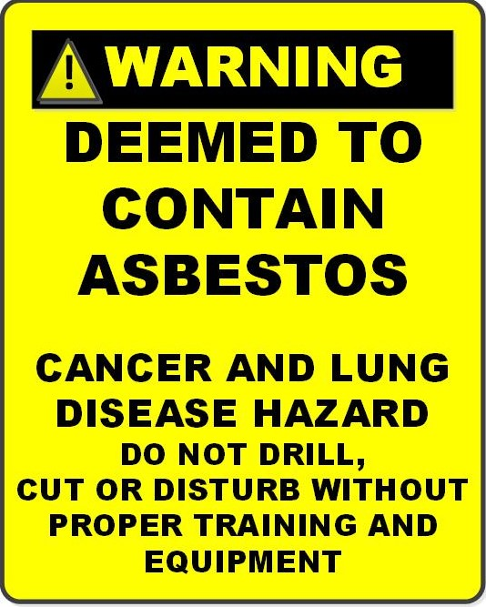  90mm high, 40 mm wide | Criteria  For fully sealed equipment where the insulation or internal material is not readily accessible and no testing has been carried out.  For accessible surfaces that have not been tested but are assumed to contain asbestos.  Or, where damage to the equipment would be required to collect a sample.  Location  On outer side of door or equipment item.  Frequency  Where practicable one on each side of equipment item. Otherwise at least one.  Outdoor Equipment : Use label suitable for outdoors
Directional Arrow labels  40mm x 35mm each – Set of 4 – | Criteria  Additional labels to clearly indicate location of the ACM with the arrow point.  Location  Used where it is not reasonably practicable to locate the label directly on the ACM.  Locating the label on adjacent nearby surface may be ambiguous or misleading.

References
Victoria University Procedure: - Health, Safety and Wellbeing
• Asbestos Management Procedure
Victoria University Facilities Procedure
• Asbestos Management – Removal and Renovation Procedure –
- Asbestos removal flowchart
http://intranet.vu.edu.au/AsbestosRegisters/Files/Asbestos_Removal_Flowchart.pdf

Audience
Key stakeholders who may be assisted by this guideline include the Asbestos Co- coordinator, Asbestos Consultant, Environmental Hygienist, Contracted Maintenance Provider, any contractors who may be working on or near asbestos containing materials.

Guideline Control
This section does not need to be published visibly if the Guideline is being presented on an Intranet or Internet page.  Guideline Owner: | Director Facilities
Policy Owner: | P & C Director

Date Approved:
Date Effective: | Dec 2015
Guideline History: | Version 2: Provided Dec 2015  Version 4: Updated following Oct 2018 review.
Version approval date | Summary of changes

