Concept Proposal and Business Case
New Higher Education Award Course, Major, Double Degree or Dual Award

Use Part A of this template to seek approval for a Concept Proposal to progress to a full Business Case, which subsequently involves completing Part B, including proposals to replace existing courses with substantially different offerings, and degrees developed by VU Research.

For suites of courses or offers that are interrelated, separate Business Cases may not be required if the evidence of demand and competition is similar. However, the Course Evaluation template for financial modelling must be completed.

Part A of this template is NOT required for:
- Addition of nested qualifications to existing courses (for example, a diploma that comprises the first year of an existing bachelor degree)
- New mode of delivery for an existing course (refer directly to Part B of this template)
- Non-award courses (refer directly to the Non-Award Course template)
- Pathways (refer directly to Business Case for Pathway Development).
Following endorsement from the Executive Dean (Proposing College) or Director, Transnational Education Partnerships (for VU Sydney/Brisbane, offshore and partnered delivery), the Concept Proposal should be submitted to the Deputy Vice-Chancellor Tertiary Education (DVC-TE) for consideration. If endorsed to proceed, the full business case should be submitted to the Tertiary Education Executive Committee (TEEC) for consideration via DVC.TE@vu.edu.au.

If the Business Case is endorsed by the TEEC, it will be submitted to the DVC-TE for approval and move into the curriculum development phase before being considered by the College Advisory Committee (CAG), Courses Committee, and Academic Board. Please refer to the existing Courses Lifecycle Policy and Procedures.

Courses must not proceed to development prior to receiving approval of the Concept Proposal and Business Case by the DVC-TE.

Refer to the Courses Lifecycle – Concept Proposal and Business Case (HE) Procedure.

PART A1: CONCEPT PROPOSAL DETAILSinte
Proposed Course Title: | <insert text>
Proposing College: | <insert text>
Delivery Partners (VU Online, VU Sydney/Brisbane etc): | <insert text>
Proposed Start Date: | <insert text>
AQF Level: Choose an item. | Course Offered: Choose an item.
Undergraduate: Choose an item. | Postgraduate: Choose an item.
Other Award Type: Choose an item. | Adding a Major: Choose an item. Supply Name:
New Delivery Location: Choose an item. | Mode/s of Delivery: Choose an item.
Funding source/s Choose an item.

Enrolment Type: Choose an item. | CRICOS Code: Choose an item.
Includes nested qualifications: Choose an item. | Requires professional accreditation: Choose an item.
Is the course in line with the Block Principles? Choose an item.
Is the course in line with existing course architecture rules? Choose an item.
Where the Proposal involves partner delivery (interstate or overseas), Transnational Education Partnerships must be engaged as part of this initial evaluation.
Proposed Location/Partner(s): | <insert text>

PART A2: BRIEF PROGRAM OVERVIEW
Consultation with Data Insights is advised
- Brief overview of the course or major and market demand, including:  - Intended student cohort/s (e.g. school leaver, international…)  - Summary of market demand and workforce data  - Competitor analysis  - Distinctiveness – how the course will be differentiated in the market  - State the Google Search Volumes – the number of monthly Google searches for course titles in the proposed market. | <insert text – Maximum 250 words>
- Note expected graduate outcomes and professional recognition (where relevant), including contribution to the UN Sustainable Development Goals (SDGs). | <insert text>
- Note whether the course requires work placements. | <insert text>
- Comment on the alignment of the course with the VU Strategy, including Doing Dual Differently, where relevant. | <insert text>
- List the number of new and existing units (a unit-by-unit course structure is not required at this stage). | <insert text>
- List any units that will require in-person delivery to utilise labs, specific equipment or other necessary requirements for completion of any units. | <insert text>
- Workforce capability and capacity: State whether VU has the expertise to develop and deliver the content or would need to hire new staff. | <insert text>
- Comment on whether the course will increase student load, replace an existing course, supplement, complement or impact existing courses (including VU TAFE). | <insert text>

PART A3: DECISION TO PROGRESS TO FULL BUSINESS CASE
Executive Dean (Proposing College) | Endorsed | ☐ Yes | ☐ No | Date
 | Name
 | Signature
Chief International Officer | Endorsed | ☐ Yes | ☐ No | Date
 | Name
 | Signature
Deputy Vice-Chancellor  Tertiary Education | Approved | ☐ Yes | ☐ No | Date
 | Name
 | Signature

PART B1: FULL BUSINESS CASE FOR HE AWARD, MAJORS, DOUBLE DEGREES AND DUAL AWARDS

- Describe the course structure: State if the course will include work placements, majors, capstones, and any distinctive elements compared to competitor offerings.
<insert text – Maximum 100 words>

- Provide an image of proposed course structure, including the identification of existing and new units.
<insert image>

- If an exception to course architecture rules is requested, please provide the reasoning. Valid reasons include:
- Professional accreditation requirements
- Student feedback suggested unit selection flexibility is key to selecting the course
- Without these options, demand will be curtailed thereby putting viability of the course at risk
- To minimise the need to run low volume units
<insert text – Maximum 100 words>

- Provide details of the suitability of the proposed course plan to rolling enrolment.
<insert text – Maximum 50 words>

- Cohort/s that the offer/course is pitched towards (i.e. school leaver, part-time student, international student, professional person). What are the offer’s unique value propositions to the intended market? (This will assist Marketing in promoting the key features of the offering).
<insert text – Maximum 100 words>

- Details of proposed cross-College and/or TAFE units, where applicable.
<insert text – Maximum 50 words>

- If applicable, provide a:
- Summary of internal pathways and relationships to existing VU award or non-award courses.
- Summary of external pathways and relationships to existing offshore and partner award or non-award courses.
<insert text – Maximum 50 words>

- Details of any nested and exit qualifications (exit points) within the proposed new award course.
<insert text – Maximum 50 words>

PART B2: EVIDENCE OF DEMAND, COMPETITION AND EMPLOYMENT OUTCOMES
Consultation with Data Insights is required
Important Note: If an approved VU course, or major, is to be offered with an existing partner either interstate or overseas, completion of B2 is NOT required – please refer to B3 – but if not approved by VU, B2 must be completed.

- Summary evidence of demand:
- Demand analysis must show new demand, rather than taking student load from existing VU courses. For completely online courses, consultation with VU Online must occur. | <insert text>
- Tailor evidence to the cohort/s that the proposal is pitched towards. Evidence may include details of VTAC and other offers made for similar courses in Victoria and other states, and/or evidence of industry growth or change. | <insert text>

- Detail the competitor analysis – who else delivers the same or similar courses in Victoria and Australia?
- State how the proposed course will differ and be distinctive in the market.
<insert text>

- Evidence regarding the employment and other graduate outcomes expected from the new award course or major. Evidence may include:
- Employment growth data, graduate employment data (where available), and job vacancy figures within the industry or professional discipline related to the proposed award course or major. | <insert text>
- Details of new industry expansions, initiatives or government policy and funded projects, which are anticipated to generate new demand for HE qualified workers. | <insert text>
- Expert opinion from industry peak bodies, course/college external advisory committees, or research bodies indicating employment trends or outcomes. | <insert text>
- Details of how the content and coverage of the proposed award course or major aligns with the needs and expectations of relevant industries or disciplines. | <insert text>
- The requirements for professional accreditation or industry recognition, if relevant. | <insert text>
- Other information where relevant. | <insert text>

PART B3: INTERSTATE OR OVERSEAS DELIVERY (complete if relevant)
This section relates to the proposed delivery of an existing award course interstate or overseas. If the proposed award course or major is new to VU, the requirements of B2 must be completed in addition to this section. If adding an approved new major with an existing partner (e.g. VU Sydney/Brisbane), please complete b), c), d), e), f) and g).

- Details of the planned institutional partner/s, including:
- Alignment with the requirements of the Third-Party Arrangements Policy and Third-Party Arrangements Procedure. | <insert text>
- Any existing Memorandum of Understanding (MoU) or contractual arrangements with the proposed partner/s and their current status (indicative schedules should be attached). | <insert text>
- A summary of the due diligence conducted, including background information on the partner institution, including its legislative status in the home country. | <insert text>
- Legislative requirements for offering a course in the host country, if any. | <insert text>
- If the partner institution qualification constitutes part of the delivery (as a pathway or dual award), state the AQF equivalent level as guided by the Department of Education (DoE) Country Education Profiles. | <insert text>

- Provide a summary rationale for the introduction of the new delivery location, including alignment to the VU Strategy and the International Plan.
<insert text – Maximum 50 words>

- Summarise the evidence of demand in the market for that provider (e.g. details of market analysis; evidence of industry growth or change).
<insert text – Maximum 50 words>

- State what professional accreditation or industry recognition is required in the proposed location (if relevant).
<insert text – Maximum 50 words>

- Provide a competitor analysis, i.e. who else delivers the same or similar award course or majors in the proposed location?
<insert text – Maximum 50 words>

- Provide evidence regarding the employment and other graduate outcomes expected from the new award course or major in the proposed location.
<insert text – Maximum 50 words>

- Identify risks and how these will be mitigated.
<insert text – Maximum 50 words>

- Provide details of award course or major profile:
- Summary of internal pathways and relationships to existing VU award courses.
- Summary of external pathways and relationships to existing offshore and partner award courses.
<insert text – Maximum 50 words>

- Outline the proposed delivery mode and breakdown of responsibilities for delivery.
<insert text – Maximum 50 words>

PART B4: JOINT AWARDS
The Business Case for Joint Awards must be prepared and presented to University Council in the first instance, to obtain approval for use of dual badging on a VU testamur, or for VU to be dual-badged on a testamur issued by another institution.

Please see the Courses Lifecycle – Dual and Joint Awards Procedure for further details about this process.

PART B5: FINANCIAL MODELLING
Financial modelling must be included with the Business Case:
- Financial modelling must be performed using the Financial Modelling Tool. Please complete the:
- Course Evaluation Template; and
- Course Evaluation Template Approval Form,
- Web Link: https://intranet.vu.edu.au/Finance/FinanceForms.asp
- You must consult with your relevant College Finance Business Partner and the Planning and Performance team (for load estimates).
- Please copy and paste the Detailed Financials Tab from the spreadsheet into the box below.
<insert the Detailed Financials Tab from the Course Evaluation Template>

PART B6: IMPLEMENTATION PLAN

- A high-level Implementation Plan must be provided to the TEEC, which includes details of the following:
- the anticipated date the course will be entered into the Course Approvals and Management System
- the anticipated date the proposal will be submitted to the College Course Advisory Group
- the anticipated date the course will be considered by Academic Board
- enrolments
- the anticipated date the course will be ready to commence
- a brief summary of intended marketing initiatives

- If additional resources are required to develop the course, they must be identified. Resource availability and the costs of the additional resources must also be listed.
<insert text – Maximum 50 words>

PART B7: EXIT STRATEGY CONSIDERATIONS
- If the course is not successful and does not meet targets.
- What remediation activities will be undertaken at the end of its first year of operation? For example, improved content, increased marketing and/or adjusted expectations.
- What would be required at the end of Year 2 or 3 if it continued to not meet expectations? For example, teach-out of units, transfer students to similar courses or transfer students to other institutions.
The Exit Strategy must include what the trigger point would be for these actions (i.e. not meeting 50 per cent of Year 1 target, not meeting 50 per cent of Year 3 target, mitigation in Year 1 doesn’t result in improvement).

Note: The level of detail required will depend on the level of resources and costs involved.

PART B8: CONSULTATION
Evidence of consultation with relevant stakeholders must be presented. Please complete relevant sections below (insert additional rows if required).
Any other College involved in delivering any units that form part of the proposed new HE Award course or major, new delivery location/partner for a course or new mode of delivery
Name |  | Position & College | Date | Comments
First Year College (mandatory for all courses that offer first year undergraduate units)
Name |  | Position & College | Date | Comments
VU TAFE (e.g. pathways, micro-credentials)
Name | Position |  | Date |  | Comments
Planning and Performance (load estimates in the financial modelling tool)
Name | Position |  | Date |  | Comments
Finance (for completion of financial modelling)
Name of College Finance Business Partner |  |  | Date |  | Comments
Data Insights (for demand, competition and job/graduate outcomes)
Name | Position |  | Date |  | Comments
VU Global (for International onshore)
Name | Position |  | Date |  | Comments

Transnational Education Partnerships (for VU Sydney/Brisbane, offshore and partnered delivery)
Name | Position | Date | Comments
Moondani Balluk
Name | Position | Date | Comments
Relevant Support Units (e.g. Academic Quality and Standards, Student Services, Student Administration, Learning Support, Future Students & Marketing, Library, ITS, Facilities…)
Name | Position & Support Unit | Date | Comments
VU Online (please note: consultation must occur with VU Online for delivery to be completely online)
Name | Position & Organisation | Date | Comments
Any partner institutions within Australia or overseas who have a role in delivery of the proposed new HE Award course or major
Name | Position & Institution | Date | Comments
For professionally accredited award courses or majors, accrediting body advice must be sought and included within the Business Case.
<insert text – Maximum 50 words>

PART B9: ENDORSEMENTS AND APPROVAL OF FULL BUSINESS CASE
Data Insights | Consulted | ☐ Yes | ☐ No | Date
College Finance Business Partner | Consulted | ☐ Yes | ☐ No | Date
Executive Dean (Proposing College) | Endorsed | ☐ Yes | ☐ No | Date
 | Name
 | Signature
Chief International Officer | Endorsed | ☐ Yes | ☐ No | Date
 | Name
 | Signature
Tertiary Education Executive Committee | Endorsed (as per meeting minutes) | ☐ Yes | ☐ No | Date
Deputy Vice-Chancellor  Tertiary Education | Approved | ☐ Yes | ☐ No | Date
 | Name
 | Signature

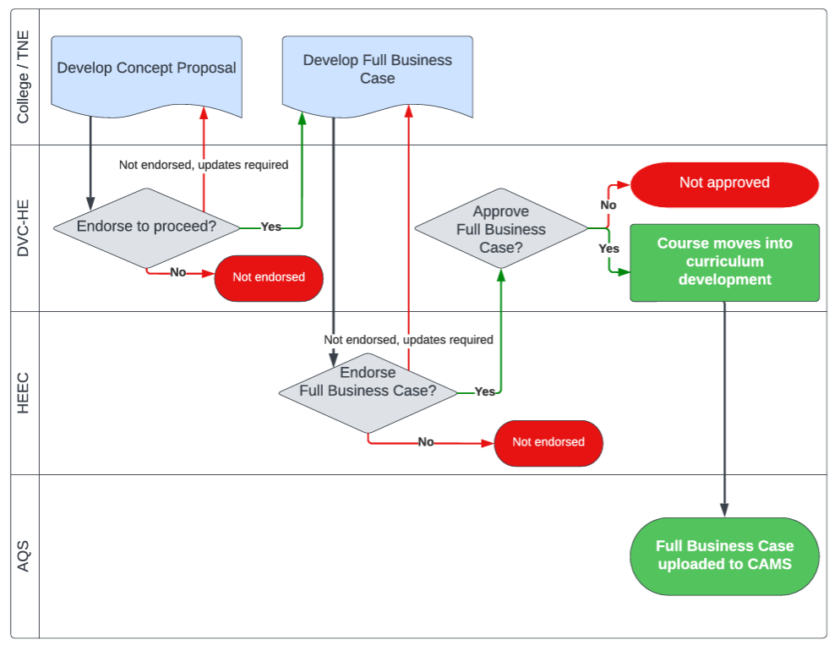
Important Links

- Courses Lifecycle Policy

- Courses Lifecycle – CPBC Procedure

- Concept Proposal template

- Non-Award Course template

- Business Case template

- Course Evaluation template (financial modelling)

- Course Evaluation template Approval Form

