Scope: To document the contributing factors, root cause and controls for an incident or near miss within the VU Incident reporting system

Steps:

1. Once the report has been reviewed and processed ( no longer in Pending).

Access the report using the Incident number and filter within the Incidents/ Incidents lists drop down box.

Click on the Investigation tab

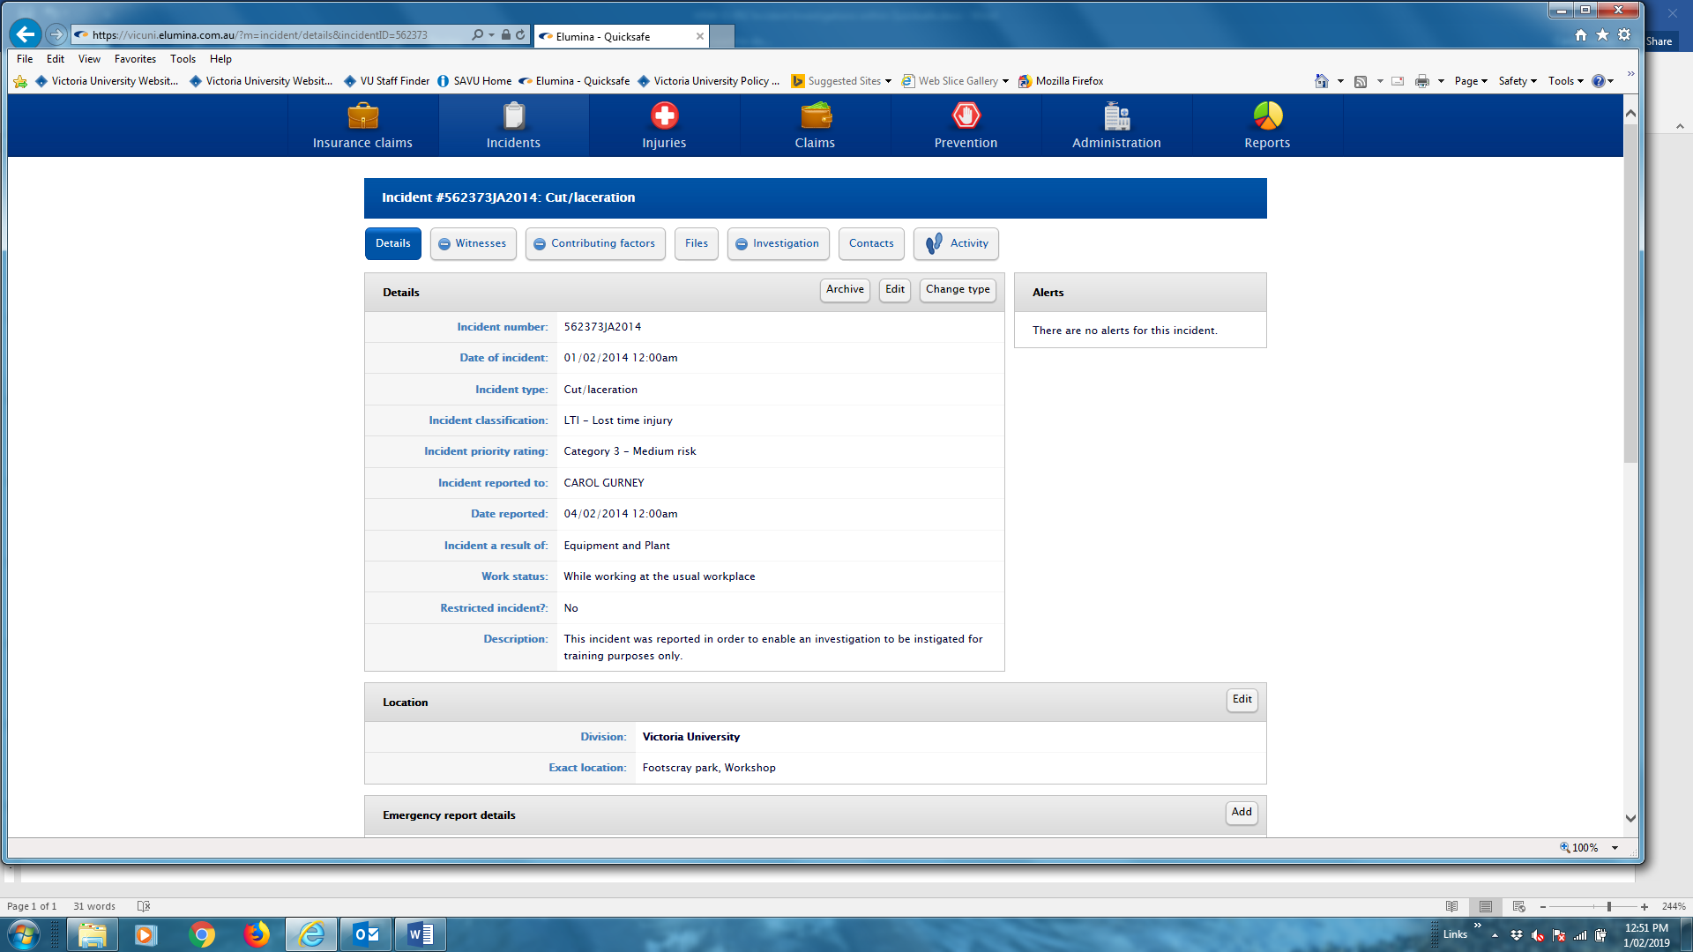

2. The investigation status allows you to assign a person to do an investigation and email them the request.

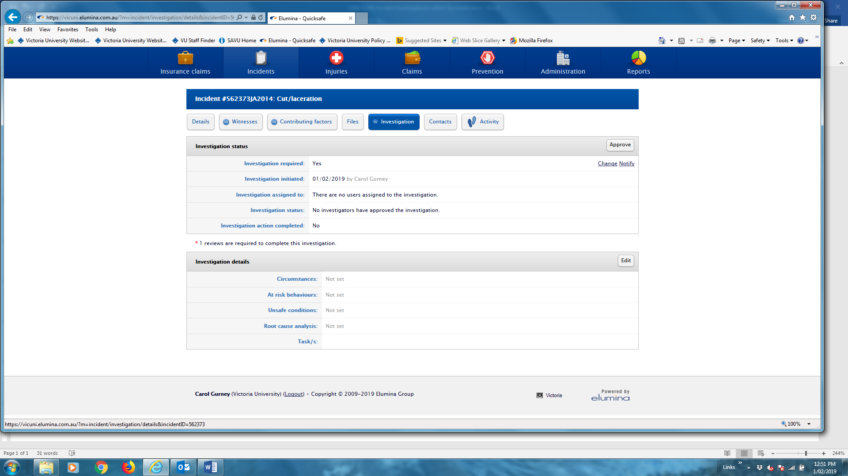

Change button:

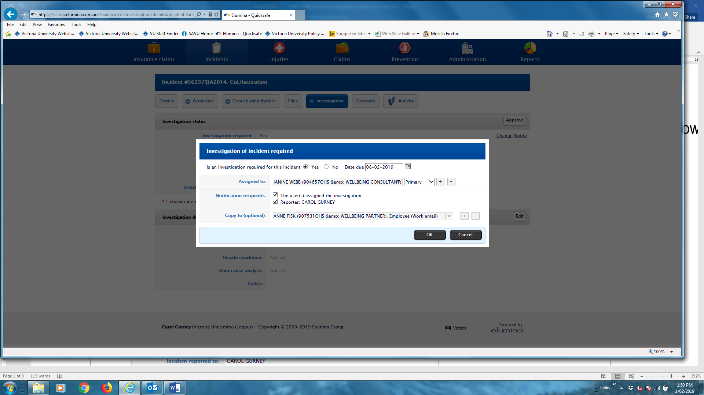

If you click OK then the system asks to confirm that notification email is required.

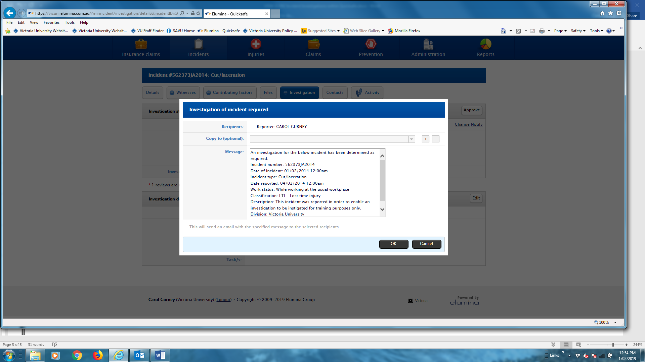

At this point you should not approve as the second section has not been completed.

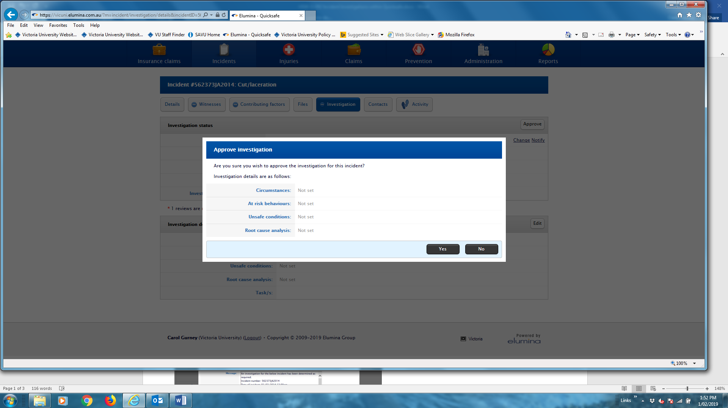

3. The investigation details section has free text for the contributing factors and root cause discovered as part of the investigation.

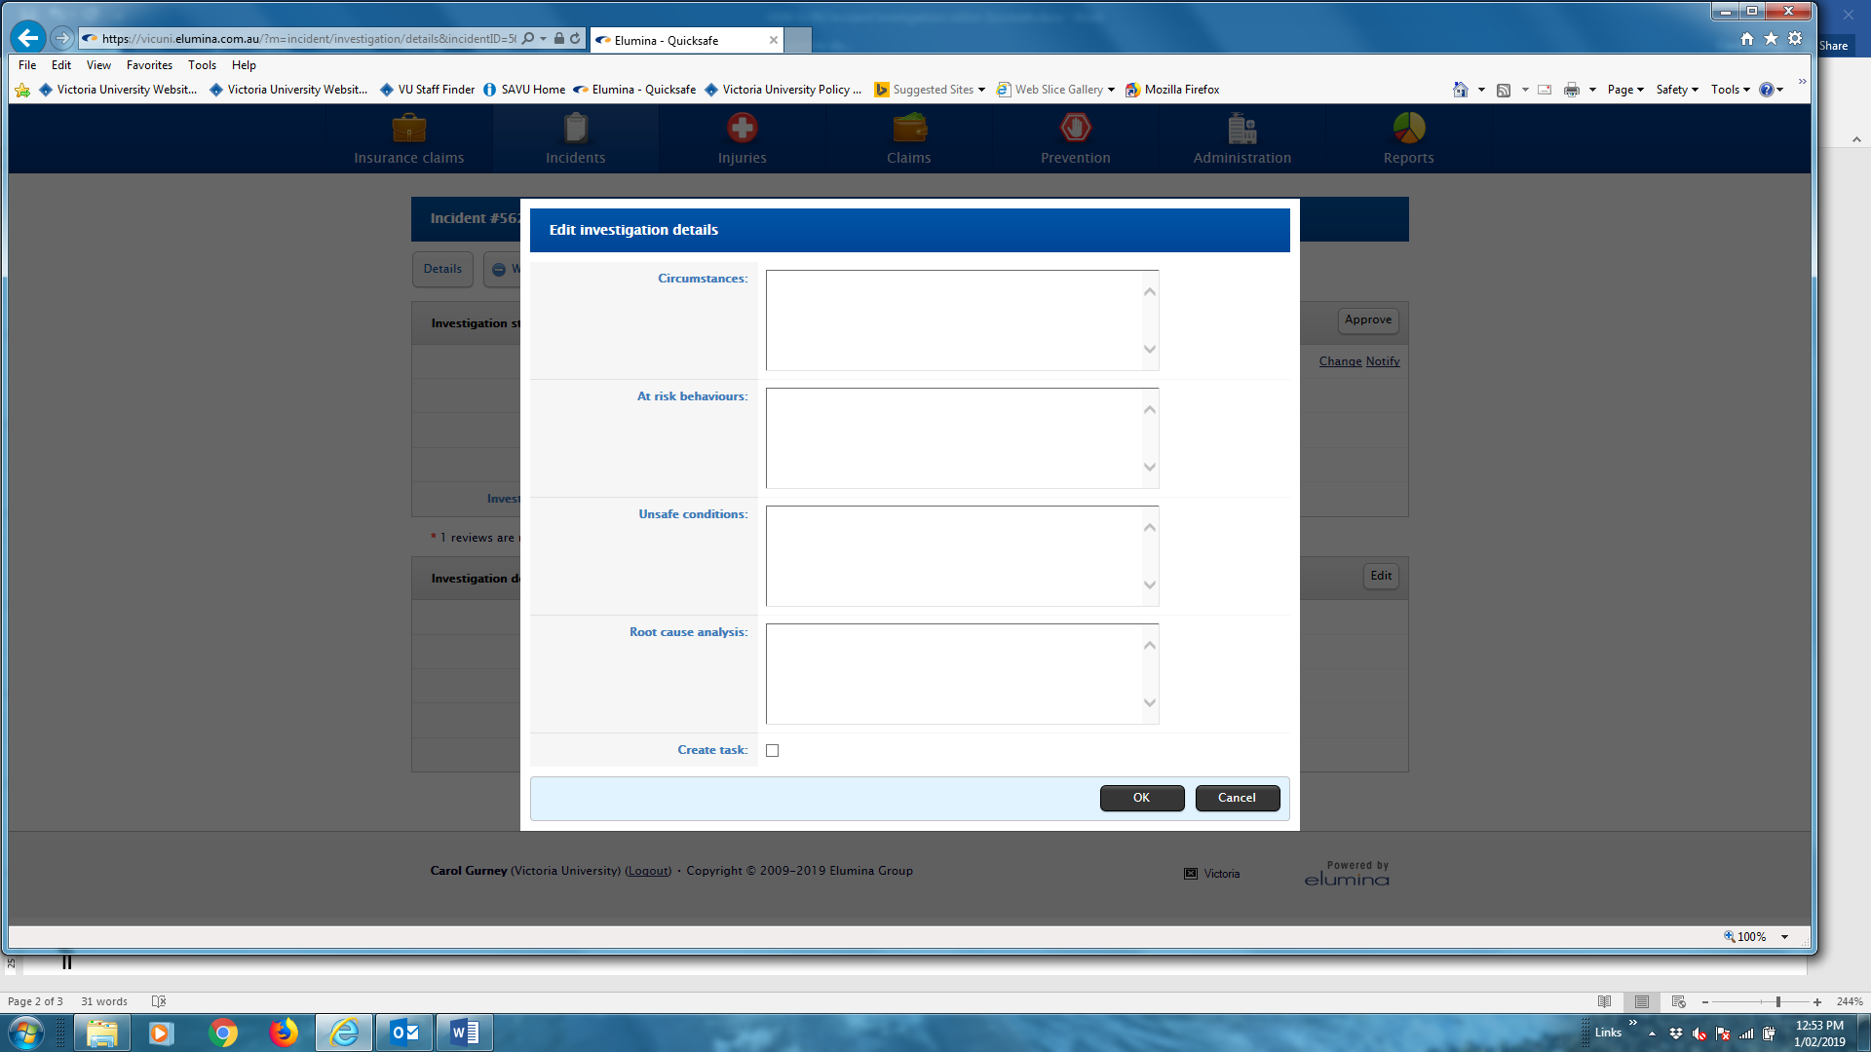

Circumstances

This is an explanation of the lead up to the event. Who did what? What equipment was involved? Was something in the environment a factor.

At risk behaviors

This can be someone not doing something or doing something incorrectly. It may not be their fault i.e did not know the procedure, had not been trained or a third party involved.

Unsafe conditions

This can be either with the equipment being used or the location the incident occurred.

Root cause analysis

There is usually more that one root cause. Look at which of the causes you can take action to correct.

Create task

If you tick here it will automatically go to the section to set the task. If you do not tick you can do the task later.

Example filled in

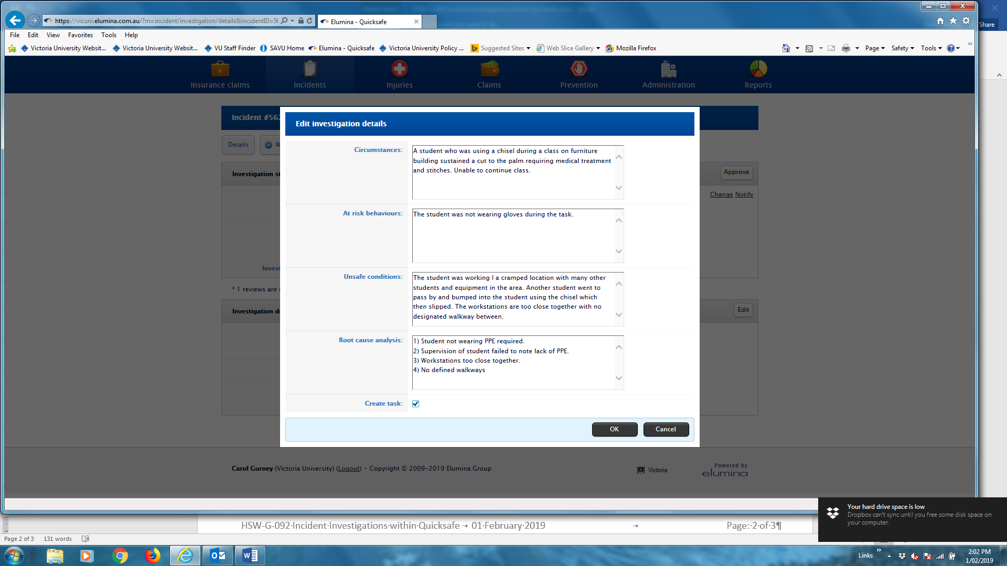

The task section can be done at this point or via the Activity in the menu bar.

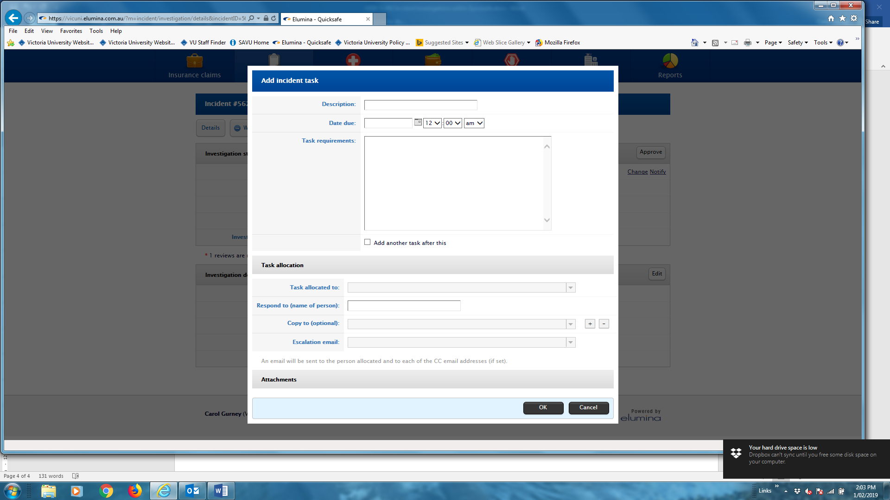

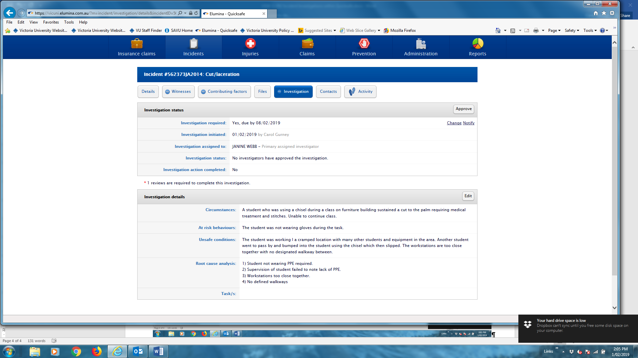

Once this is completed you can then approve

